Comparison of KNN and SVM Algorithms in Facial Image Recognition Using Haar Wavelet Feature Extraction

Neneng Rachmalia Feta

Information Systems and Technology
Indonesia Cyber University
Cyber-univ.com
nrachmaliafeta@cyber-univ.ac.id

Abstract
To process all the pixels in the face image, feature extraction can be performed using the Haar Wavelet method so that it processes identifiers with lower dimensions. However, a classification algorithm must separate the distance between classes with minimal data to classify low-dimensional facial images. KNN and SVM algorithms are classifiers that can be used for facial image recognition. When classifying images, SVM creates a hyperplane, divides the input space between classes and classifies based on which side of the hyperplane the unclassified object is placed when it is placed in the input space. KNN uses a voting system to determine which class an unclassified object belongs to, taking into account the nearest neighbor class in the decision space. When classifying, KNN will generally classify accurately, resulting in some minor misclassifications that plagued the final classified image. This study aims to compare the two algorithms on image identifiers with low dimensions resulting from haar wavelet extraction. The research results obtained are facial image classification using the haar wavelet extraction method using the SVM algorithm to obtain an accuracy of 98.8%. Whereas when using the KNN algorithm, the accuracy obtained is 96.6%. The results of this study show that the SVM algorithm produces better accuracy in facial image recognition using haar wavelet feature extraction compared to the KNN algorithm. The SVM algorithm can recognize facial images even though it uses image training data with various face poses and sizes, resulting in higher accuracy.

Keywords: facial image recognition, feature extraction, Haar Wavelet, SVM algorithm, KNN algorithm, low dimension, accuracy.

Abstrak
Agar memproses keseluruhan piksel di dalam citra wajah, dapat dilakukan ekstraksi ciri menggunakan metode Haar Wavelet sehingga diproses penciri dengan dimensi yang lebih rendah. Namun untuk mengklasifikasikan citra wajah dengan dimensi rendah tersebut dibutuhkan algoritma klasifikasi yang dapat memisahkan jarak antar kelas dengan data yang minimal. Algoritma KNN dan SVM merupakan pengklasifikasi yang dapat digunakan untuk pengenalan citra wajah. Saat mengklasifikasikan gambar, SVM membuat hyperplane, membagi ruang input antara kelas dan mengklasifikasikan berdasarkan sisi mana dari hyperplane objek yang tidak terklasifikasi mendarat ketika ditempatkan di ruang input. KNN menggunakan sistem pemungutan suara untuk menentukan kelas mana yang dimiliki objek yang tidak diklasifikasikan, dengan mempertimbangkan kelas tetangga terdekat di ruang keputusan. Saat mengklasifikasikan, KNN umumnya akan mengklasifikasikan secara akurat; namun, ini menghasilkan beberapa kesalahan klasifikasi kecil yang mengganggu gambar akhir yang diklasifikasikan. Penelitian ini bertujuan untuk membandingkan dua algoritma tersebut pada penciri citra dengan dimensi yang rendah hasil ekstraksi haar wavelet. Hasil penelitian yang diperoleh adalah klasifikasi citra wajah dengan metode ektraksi haar wavelet menggunakan algoritma SVM mendapatkan akurasi sebesar 98.8%. Sedangkan pada saat menggunakan algoritma KNN akurasi yang didapatkan sebesar 96.6%. Hasil penelitian ini diperoleh bahwa algoritma SVM menghasilkan akurasi yang lebih baik pada pengenalan citra wajah menggunakan ekstraksi ciri haar wavelet dibandingkan dengan algoritma KNN. Algoritma SVM memiliki keunggulan dapat mengenali citra wajah meskipun menggunakan data latih citra dengan pose dan ukuran wajah yang beragam, sehingga menghasilkan nilai akurasi lebih tinggi.

Kata Kunci: pengenalan citra wajah, ekstraksi ciri, Haar Wavelet, algoritma SVM, algoritma KNN

INTRODUCTION

Facial image recognition is an application of artificial intelligence. Facial image recognition involves using algorithms and computational techniques to identify a person's identity based on the features contained in the image. But the face is one object that is difficult to model. This is because many factors affect the facial image, such as age, lighting, shooting technique, orientation, pose, and facial expressions (Desylvia, 2014).
Image data in computer vision is a visual representation of real-world objects generated by devices such as cameras or sensors. A digital image is represented by a matrix of total dimension two whose elements have coefficient values (Wilhelm & Mark, 2016). The coefficient value is the brightness level at the location of the x,y matrix. The amount of image data varies depending on factors such as resolution, constituent bands, and the storage format used. Each image consists of a large number of pixels, where each pixel can store color or brightness information. For example, a picture with a resolution of 1920x1080 pixels has about 2 million pixels.
Facial image recognition with large resolution requires high computational resources. When the data to be processed is extensive and requires speed, it will require a computer with high performance, and building it requires a large amount of money (Aminudin & Cahyono, 2019). To not process all the pixels in the face image, a feature extraction process can be carried out that represents the texture features and shape of the face object in the digital image (Ginanjar & Feta, 2019).
A study on digital image classification and feature extraction was performed by (Ahmad et al., 2011) to classify weed images in real-time. This study uses the haar wavelet algorithm to extract image features and uses the KNN classification algorithm. The results of this study obtained a high accuracy value of 94% and a response time of 40ms. (S.Raikwal & Saxena, 2012) researched the performance of the SVM and KNN classification algorithms using medical data sets. The results of the study state that the accuracy produced by the SVM algorithm is better than the KNN algorithm when using more training data. And the time needed to create a classification model for 1000 training data for the SVM algorithm takes 3,273 seconds, while for the KNN algorithm, it takes longer, namely 9,155.
Classification using the haar wavelet feature extraction method can decompose digital images into smaller dimensions. This can be used to build a model for facial recognition classification with a faster processing time. Meanwhile, the KNN algorithm in research (Ahmad et al., 2011) produces a high accuracy of 94%. Then the SVM algorithm in research (S.Raikwal & Saxena, 2012) has the advantage of producing higher accuracy than the KNN algorithm. Therefore, in this study, a comparison of the KNN and SVM algorithms was carried out using haar wavelet feature extraction for facial recognition in digital images.
Purpose of the study and techniques employed in the study
- To determine which algorithm's performance yields higher accuracy
- To determine which level of haar cascade makes higher accuracy
Contribution of the study: This study provides insight into the research results to inform the comparison of her KNN algorithm and SVM in face recognition using haar wavelet feature extraction.

RESEARCH METHODS

Time and Place of Research
This comparative study of facial image classification algorithms was carried out for three months, from early February to mid-May. Meanwhile, facial image data collection uses secondary data sources.

Data, Instruments, and Data Collection Techniques
The data used in this study uses facial images in jpg file format. Each pixel of the face image has three color elements: red, blue, and green. The facial image data resolution used is 196x196 pixels. The number of classes used in this study was 31 classes. Each data class consists of 10 image data. The total data used in this research is 310 facial image files.

Data Analysis Technique
The facial image data used in this study is quantitative. The facial image data compiler consists of a 3-dimensional matrix measuring 196x196 pixels. Each pixel in the face image has three constituent values with values ranging from 0 to 255.

Image Preprocessing
The preprocessing performed on the facial image data consists of 2 stages: conversion into a grayscale image and a histogram equalizer. In the first stage, image data with three constituent elements, red, green, and blue (RGB), is reduced to a grayscale image so that the number of pixels to be computed is reduced by 2/3 percent.
After the face image is converted to grayscale, histogram equalization is performed so that the distribution of the grey degree values in the image is even (Al-Aidid & Pamungkas, 2018). Calculation of histogram equalization is done by using the equation:

$$w=\frac{C_{w}.256}{n_{x}n_{y} } ............………....................(1)$$

We can see in equation (1), where w is the grey value of the histogram equalization results, C_{w} is the cumulative histogram of w, 256 is the upper limit value of the grayscale image (8 bits), n_{x} and n_{y} are the image dimensions consisting of column and row sizes.

Feature Extraction
Feature extraction is a feature vector interpreted as an n-dimensional encode vector aiming to index an image's contents and database parts. The components of a feature vector are used to compare images by computing image analysis and processing techniques with other images. The features that have been extracted are then used as parameters or input values to distinguish one object from another at the identification or classification stage (Situmorang et al., 2019).

Haar Wavelet
Haar Wavelet is a signal transformation method with the easiest and simplest kernel to compute compared to other Wavelet transformations (Ginanjar & Feta, 2019). Image feature extraction or image feature capture with Haar Wavelet can accurately describe texture and shape features. Haar Wavelet divides the image into four subsections, including LL, LH, HL, and HH, through decomposition (Reisenhofer et al., 2018). The LL subsection is an approximate part of the image and functions as an identifying image, while the other subsections are the detailed part of the image itself. LL subdivisions can be further divided into four new subsections through the decomposition process, and so on. The number of decomposition iterations is expressed as the wavelet level. In this study, they use levels of Haar Wavelet decomposition from levels 2, 3, 4, 5, and up to level 6. An example of a subsection of the results of the Haar Wavelet decomposition is shown in Figure 1.

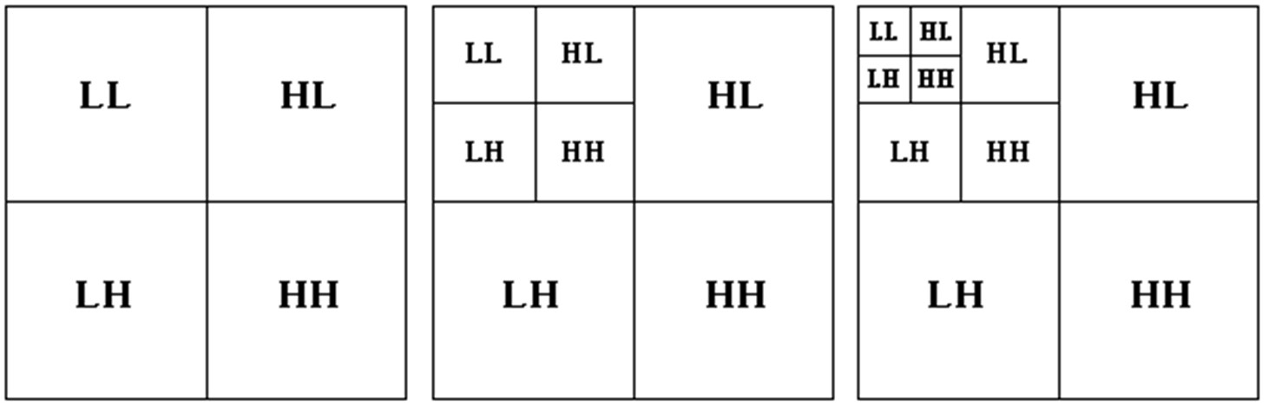
(a) (b) (c)
Figure 1. Subdivision of Haar Wavelet decomposition results (a) Level 1 decomposition (b) Level 2 decomposition (c) Level 3 decomposition

Classification
Classification is a data processing technique that determines data into predetermined groups or classes (Bahri & Lubis, 2020). This method helps create functions or models that describe the classes in the data used to predict the classes of unlabeled objects (Wijaya et al., 2021). A classification method applies an algorithm to the classification process to form data groups.

K-Nearest Neighbors
The K-Nearest Neighbor (KNN) algorithm is an object classification algorithm based on similarities to other nearby objects without knowing the data distribution (Kosasih, 2020). This method aims to classify new objects based on the shortest distance from the test image to the training data to get the KNN value. When you have obtained data from the KNN values, most of the KNN will be used as an estimate from the test image (Yulianti et al., 2022).
The KNN classification method performs the recognition process based on the number of nearest neighbors to determine the class (Ramdani et al., 2022). There are various ways to measure the closeness distance between new data and training data, including using the Euclidean distance, Manhattan distance, Minkowski distance, cosine distance, and correlation. The most commonly used is the Euclidean distance. In addition, the Euclidean distance has the best accuracy results compared to the Manhattan distance (Yohannes et al., 2019).
The Euclidean distance can be calculated using the equation:
$$d \left(X, Y\right)= \sqrt{\sum_{i=1}^{n}{{(a_{i}-b_{i})}^{2}}} .................(2)$$
Where:
$d \left(X, Y\right)$ = The Euclidean distance will be searched to find the similarity value that produces the smallest value.
$a_{i}$ = stored reference image values
$b_{i}$ = test image value
$n$ = amount of image data
$i$ = 1, 2, 3, ………, n

This study uses the Euclidean distance to measure the closeness distance between the new data and the training data; as we can see in equation (2), 𝑑 is the scalar distance of the two vectors 𝑋 and 𝑌 of the matrix with size 𝑛 dimensions. During the training phase, the algorithm stores the feature vector and classifies the training data. The same features are computed on the test data during the classification phase. The distance between this new vector and all training vectors is calculated to get the k nearest parts. Points for which a new classification is predicted are included in the most classification for those points. The following are the steps of KNN, among others (Ramdani et al., 2022):
- Determine the value of K, which is the number of nearest neighbors.
- Using the Euclidean distance equation, I calculated the distance between the test image and all images in the database.
- Sorts all objects into groups that have the smallest Euclidean distance.
- Collects the Y category, which is the nearest neighbour classification.
- The calculated query instance value can be predicted using the majority category.

SVM
SVM, or Support Vector Machine, is a classification algorithm that aims to find a separator function that can separate two sets of data from 2 different classes (Feta & Ginanjar, 2019). The SVM method works based on the principle of SRM (Structural Risk Minimization), which aims to find the best hyperplane by separating the two classes in the input space.
The Support Vector Machine method works by using a linear classification. It is then enhanced to handle non-linear cases using the kernel concept in workspaces with higher dimensions. Several types of kernels can be used, including linear, polynomial, RBF (Radial Basis Function), and Sigmoid kernels. The equations for each type of kernel are in equations (3), (4), (5), and (6) as follows (Religia, 2019):
- Linear
$K\left(x_{i}, x_{j}\right)= x_{i}^{T}x_{j} ............................ .(3)$

- Polynomial
$K\left(x_{i}, x_{j}\right)={({y x}_{i}^{T}x_{j}+r)}^{d}$, y > 0 ……….………(4)

- Radial Basis Function
$K\left(x_{i}, x_{j}\right)= exp (-y x_{i}-{x_{j}}^{2})$, y > 0 ……….(5)

- Sigmoit
$K\left(x_{i}, x_{j}\right)=tanh⁡(y x_{i}^{T}x_{j}+r)...............(6)$
The kernel used in this study is a linear kernel, which maps data from low to higher dimensions. This kernel is the simplest type of kernel, suitable for use with many features because mapping to a higher dimensional space does not improve accuracy.

K-Fold
K-Fold Cross Validation is a technique for dividing data. After a preprocessing process, data sets with class labels will be broken down into two data types, training and test data (Feta, 2022). Splitting the data into k parts allows us to stop predicting each piece of data sooner than if we didn't split it first. An illustration of data sharing using KFold is presented in Figure 2.

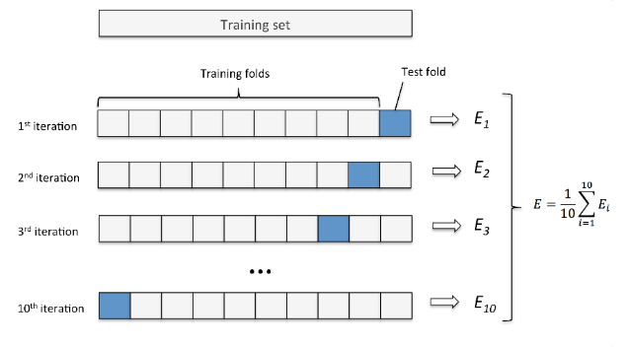
Figure 2. Data sharing using K-Fold Cross Validation

Figure 2 shows that the model that has been made is divided into K parts that are equal or close in size. The model's accuracy will be tested using the test data for each Fold and will continue with the next Fold until it's finished. Accuracy will be totalled and divided by the number of K (Nasution & Hayaty, 2019).

Procedure
This study compared KNN and SVM algorithms to obtain the best classification results. The steps used in this study are as follows:
- Data Preprocessing
- Feature Extraction
- Distribution of training data and test data (KFold)
- Calculation using the KNN algorithm
- Calculation using the SVM algorithm
- Perform data comparisons using two algorithms

RESULTS AND DISCUSSION

The image data used in this study is a facial image similar to the background. Image data were collected was carried ten times with different poses for each person. The number of people (classes) used in this study was 31, so the total facial images used in this study were 310 images. Examples of facial images from several classes are presented in Figure 3.

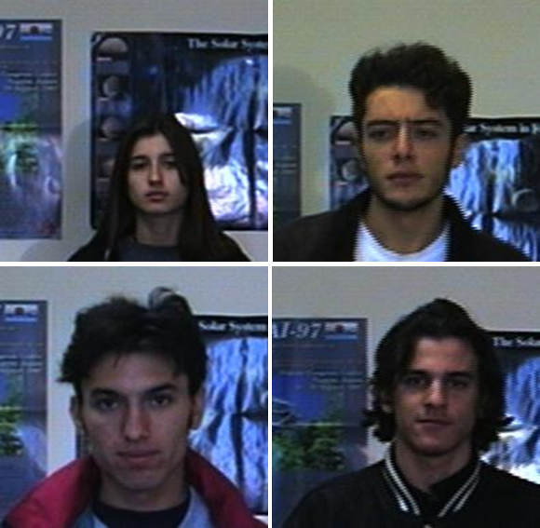
Figure 3. Examples of facial image data from several classes
A data preprocessing step was performed on 310 face images using RGB to grayscale image conversion, followed by a histogram equalizer. The original face image data is composed of a 3-dimensional matrix measuring 196x196x3 pixels; the total pixels for each image are 115,248 pixels. After being converted to a grayscale image, the number of pixels for each image is reduced to 2/3 parts, resulting in an image with a total of 38,416 pixels.
The facial image converted to grayscale is then carried out with a different process, namely the histogram equalizer. This is done because some images are taken at locations with less lighting, resulting in images that look rather dark. After preprocessing, the image equalizer histogram is brighter because each pixel in the image is recalculated, so the distribution of the grey colour degree values is even. An example of converting an RGB face image to a grayscale image and the results of the equalizer histogram process are presented in Figure 4.


- (b)

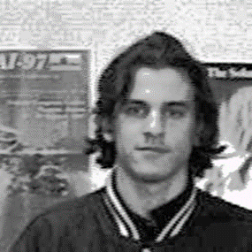
(c)
Figure 4. Example of facial image preprocessing, (a) RGB face image, (b) Grayscale image, (c) Equalizer histogram image
Preprocessed face images are characterized by extraction with the Haar wavelet algorithm. The dimensions of the face image have a resolution of 196x196. The results of image feature extraction consist of 4 parts, namely LL, LH, HL, and HH. The LL sub-section is the image approximation part and is used as an identifying image, while the other sub-sections are the detail parts of the image. LL subdivisions can be decomposed again into four new subsections, and so on, depending on the number of decomposition levels specified.

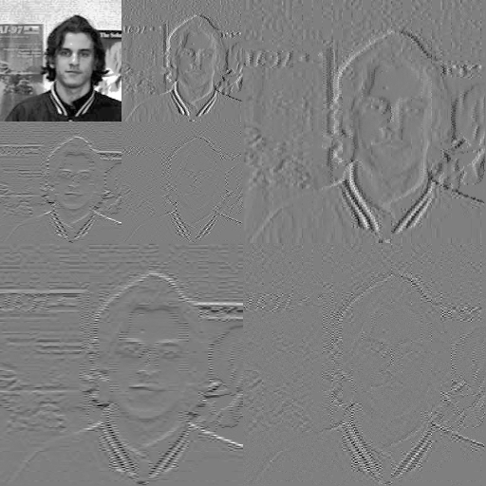
Figure 5. An example of an image decomposed by the Haar Wavelet level 2 algorithm

An example of an image decomposed using the Haar Wavelet algorithm is presented in Figure 5. In this study, feature extraction was carried out using Haar Wavelet with several levels: 2, 3, 4, 5, and 6. The greater the decomposition level, the smaller the dimensions of the image identifier are obtained. If the image identifier is plotted into the imread function on Open CV, it will no longer resemble the original image because the identifier size has much smaller dimensions. The dimensions of the extracted image approximation are presented in Table 1.

Table 1. Comparison of the size dimensions of the image characteristics decomposed by the Haar Wavelet algorithm
Level | Dimensions | Number of Pixels
2 | 49x49 | 2.401
3 | 25x25 | 625
4 | 13x13 | 169
5 | 7x7 | 49
6 | 4x4 | 16

The division of image data into training and test data is carried out to calculate the accuracy of the classification algorithm. The method of dividing the data into two parts uses KFold Cross-Validation. The K value in the algorithm states the number of data divisions into K parts. The K constant in this study was used with a value of 5, so the 310 image data were divided into five parts. A total of 4 parts of the data are used as training data, while one other is used as test data. After the accuracy value is obtained, it is continued with one other part used as test data; this is done up to 5 parts of the data to become test data.
The accuracy of facial image classification results using the KNN algorithm obtained as many as 25 accuracies. The accuracy value is obtained from each level of the Haar Wavelet decomposition resulting in 5 accuracy values based on the distribution of KFold Cross Validation data with a K value is 5. Meanwhile, the constant value of the KNN algorithm is 3. A comparison of the accuracy of each decomposition level and each KFold is presented in Table 2.

Table 2. Comparison of the results of the accuracy of each level of Haar Wavelet decomposition for each Fold using the KNN classification algorithm
Decomposition Levels | Fold | Accuracy (%)
 | 1 | 97
 | 2 | 96
2 | 3 | 94
 | 4 | 98
 | 5 | 98
 | 1 | 95
 | 2 | 96
3 | 3 | 94
 | 4 | 96
 | 5 | 98
 | 1 | 93
 | 2 | 96
4 | 3 | 94
 | 4 | 95
 | 5 | 97
 | 1 | 93
 | 2 | 96
5 | 3 | 97
 | 4 | 96
 | 5 | 92
 | 1 | 89
 | 2 | 92
6 | 3 | 94
 | 4 | 96
 | 5 | 94

Based on Table 2, facial image classification using the KNN algorithm produces an accuracy of above 89%. The highest accuracy is obtained at the wavelet 2 and 3 decomposition level, 98%, while the lowest is received at the wavelet six decomposition level, 89%. The difference in wavelet decomposition levels does not reduce the accuracy significantly, only a few percent. Meanwhile, the number of pixels between wavelet levels 2 and 6 is quite significant, namely a difference of 2,385 pixels. The KNN algorithm has succeeded in classifying facial images with minimal input data due to wavelet decomposition. Confusion matrix results of classification using the wavelet six decomposition level and the KNN algorithm are presented in Figure 6.

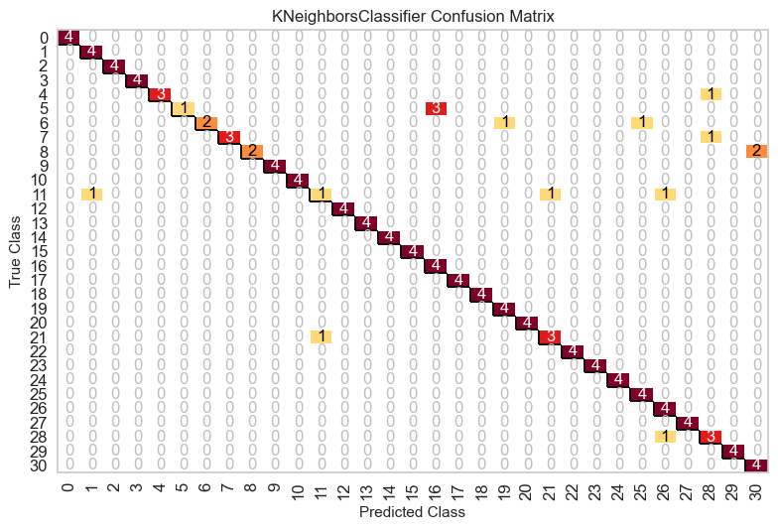
(Fold 1)
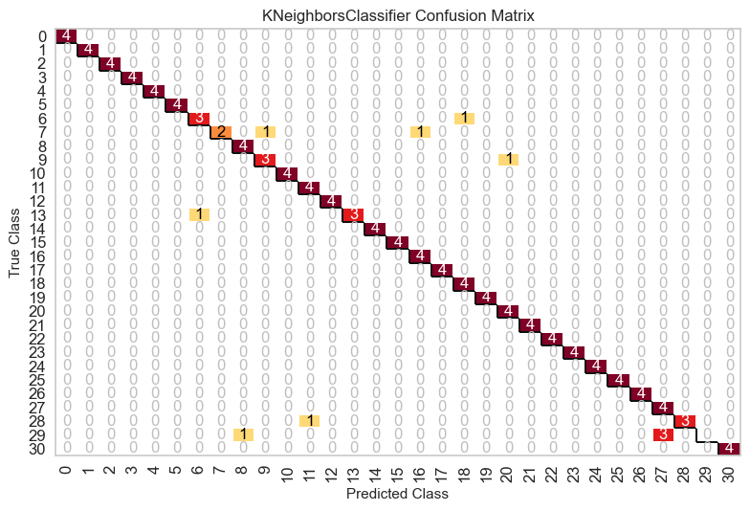
(Fold 2)
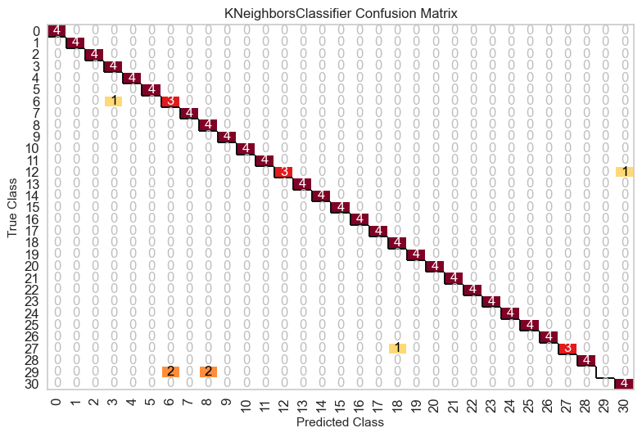
(Fold 3)

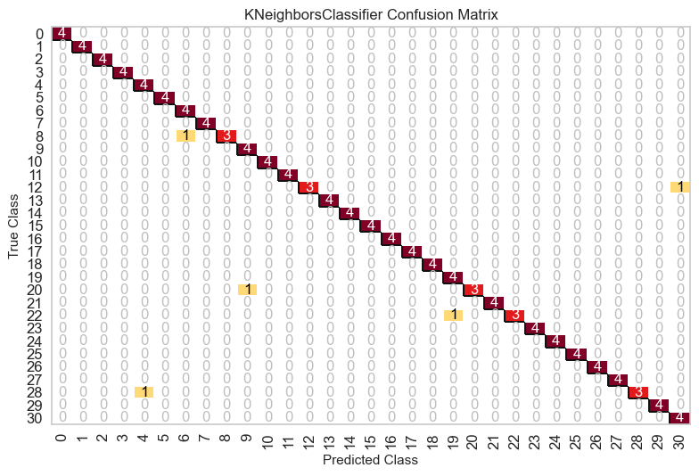
(Fold 4)

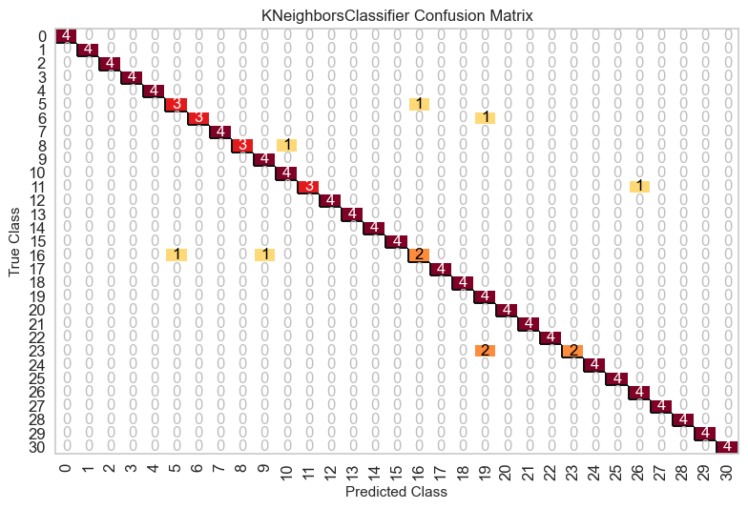
(Fold 5)
Figure 6. Comparison of the confusion matrix resulting from the classification of the KNN algorithm using wavelet decomposition level 6

In Figure 6, the Fold 1 section, it is found that only one image of class 5 and 11 face images was successfully classified correctly. Then the facial images in grades 6 and 8 were successfully classified half correctly, namely two images. In the Fold 2 and Fold three confusion matrices, 1 class of facial images cannot be classified entirely, namely class 29. Examples of facial images in class 29 that cannot be classified correctly are presented in Figure 7.

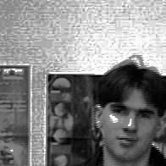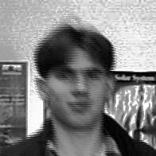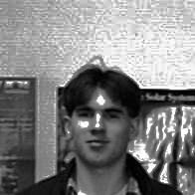
Figure 7. An example of a class 29 face image on Fold 2 and Fold 3

In Figure 7 are some examples of class 29 face images on Fold 2 and Fold 3. These facial images have images taken with the face position not fixed, have different face sizes, and have blurry images. When training and testing were carried out using the KFold algorithm, the training data could not represent class 29 facial image features.
The Haar wavelet algorithm does not segment facial objects in the image or scale facial size. The deficiencies in the Haar wavelet algorithm cause the face recognition process to be classified incorrectly. In the confusion matrix on Fold 1, 4, and Fold five, the class 29 images can be classified entirely correctly. This is because the training and testing data used have the position of the face in the middle in several poses and the size of the face in the same image.
The following process is facial image recognition using the SVM algorithm. The kernel used in the algorithm is linear. The process of dividing facial image recognition into training data and test data is done once so that the KNN and SVM algorithms in each Fold use the same training data and test data. The results of facial recognition accuracy using the SVM algorithm in several wavelet decomposition levels are presented in Table 3.

Table 3. Comparison of the results of the accuracy of each level of Haar Wavelet decomposition for each Fold using the SVM classification algorithm
Decomposition Levels | Fold | Accuracy (%)
 | 1 | 99
 | 2 | 99
2 | 3 | 98
 | 4 | 99
 | 5 | 99
 | 1 | 98
 | 2 | 99
3 | 3 | 98
 | 4 | 99
 | 5 | 99
 | 1 | 97
 | 2 | 99
4 | 3 | 98
 | 4 | 99
 | 5 | 98
 | 1 | 98
 | 2 | 99
5 | 3 | 98
 | 4 | 98
 | 5 | 97
 | 1 | 95
 | 2 | 98
6 | 3 | 96
 | 4 | 98
 | 5 | 97

Table 3 shows that facial image recognition using the SVM algorithm produces an accuracy of above 97% at each fold and wavelet decomposition level. The number of features at the wavelet decomposition level has no significant effect on the accuracy of results. So facial image recognition can use the wavelet decomposition feature level 6, which only has 16 pixels. The classification results of the confusion matrix using the wavelet six decomposition level and the SVM algorithm are presented in Figure 8.

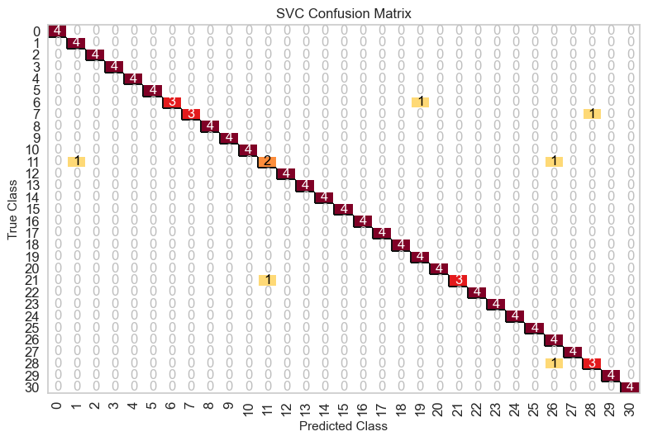
(Fold 1)
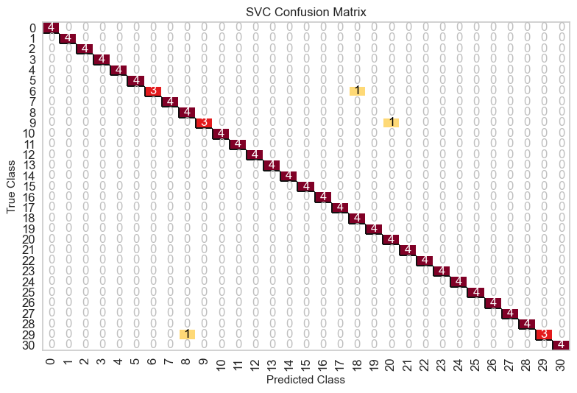
(Fold 2)

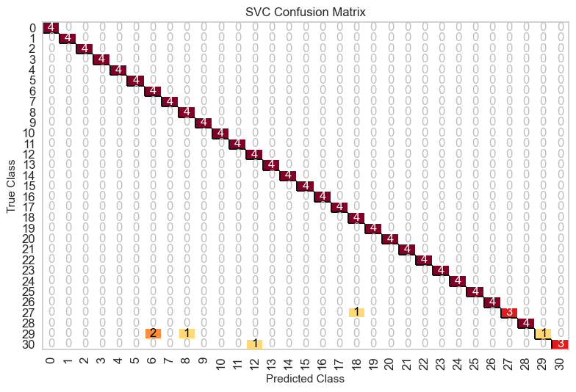
(Fold 3)

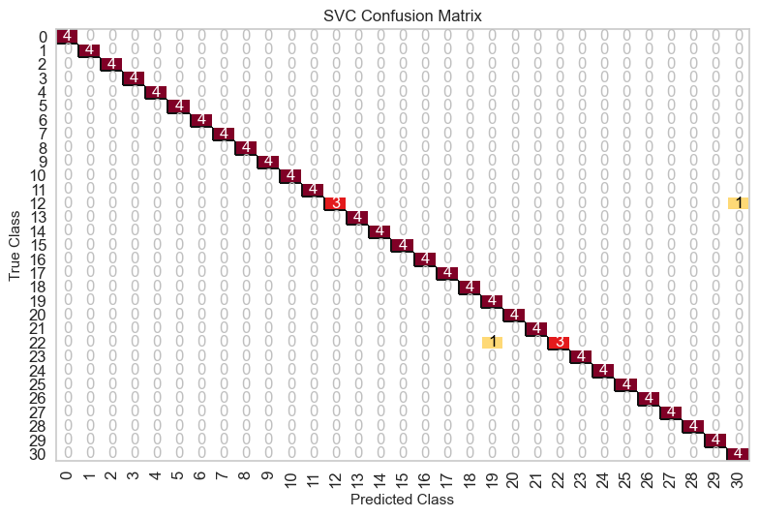
(Fold 4)

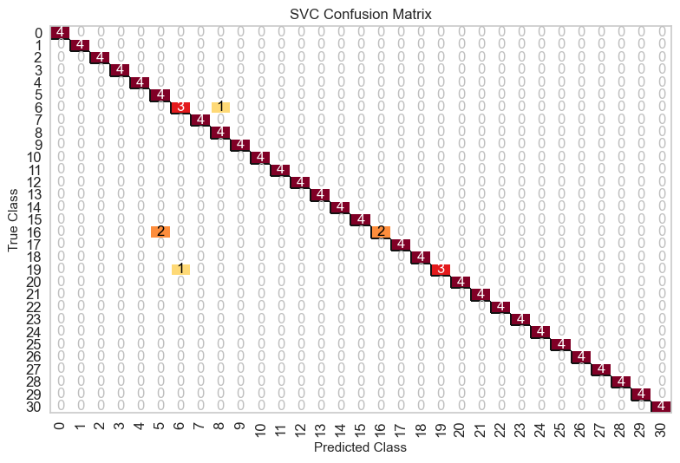
(Fold 5)
Figure 8. Comparison of the confusion matrix resulting from the SVM algorithm classification using wavelet decomposition level 6

In Figure 8, it can be seen that the confusion matrix uses the SVM algorithm at the wavelet decomposition level 6. The confusion matrix in Figure 8, Fold 1 shows that the facial image recognition classification results increase the number of face images that are successfully classified correctly compared to Figure 6, Fold 1, in which only one face image was successfully classified correctly. Then in Figure 8 Fold 3 and 4, the number of face images correctly classified increases compared to Figure 6 Fold 3 and 4. This shows that the SVM algorithm performs better in classifying facial images than the KNN algorithm. Overall Fold 1 to 5 at the wavelet decomposition level 6 shows an increase in the value of accuracy when using the SVM algorithm. A comparison of the average accuracy value between the KNN and SVM algorithms is presented in Figure 9.

Figure 9 Comparison of the average accuracy of each Fold between the KNN and SVM algorithms

In Figure 9, it can be seen that there is a decrease in the average accuracy when the Haar Wavelet level is increased. The average level of accuracy decreases in the two classification algorithms used, namely the KNN and SVM algorithms. The average accuracy obtained by the SVM algorithm is higher than the KNN algorithm. The two algorithms can classify facial images well with an average accuracy above 90% at each wavelet decomposition level.
The best average accuracy is obtained using feature extraction with a wavelet decomposition level of 2, with several features for each face image of 2401 pixels. The average accuracy generated at the wavelet decomposition level is 96.6% using the KNN algorithm and 99% using the SVM algorithm. While the average accuracy with the lowest value is obtained when using the wavelet decomposition level of 6 with the number of features for each image of 16 pixels. The average accuracy generated at level 6 of the wavelet decomposition is 93% using the KNN algorithm and 96.8% using the SVM algorithm. The comparison of the model creation time and the classification process using the two KNN and SVM algorithms is presented in Table 4.

Table 4. Comparison of model building time and classification process
Level | KNN | SVM
2 | 1.30 | 1.71
3 | 1.32 | 1.33
4 | 1.26 | 1.28
5 | 1.30 | 1.31
6 | 1.39 | 1.37

Table 4 shows the time needed to create a classification model using 310 facial images based on several haar wavelet levels. Then proceed with the classification process using the KNN and SVM algorithms. The results of this comparison stated that there was a difference of 0.41 seconds when using haar wavelet level 2, while for haar wavelets 3 to 6, there was no significant difference.

CONCLUSIONS AND SUGGESTIONS

Conclusion
Using the Haar Wavelet method, this study uses a feature extraction method on facial image data to reduce the image's dimensions so that it becomes low dimensional. The haar wavelet levels used for facial image recognition are 2, 3, 4, 5, and 6. The greater the level of decomposition, the lower the dimensionality of the image identifier so that computational costs and processing time for facial image recognition can be minimized. Each wavelet decomposition level in the facial image data is classified using the SVM and KNN algorithms. As for the classification, the data was divided into training and test data using KFold Cross Validation, with a K value of 5. Classification of facial images using the SVM algorithm resulted in a high accuracy value of 98.8%, while classification using the KNN algorithm resulted in an accuracy of 96.6%. From the results of this accuracy, it can be concluded that the SVM algorithm is superior in classifying low-dimensional facial image data from the Haar Wavelet feature extraction method compared to the KNN algorithm. The SVM algorithm can recognize facial images even though it uses image training data with various face poses and sizes, resulting in higher accuracy.

Suggestion
Based on the results of the research that has been done, a suggestion for further research is to add feature extraction features such as facial morphology as additional identifiers that can be combined with the identifier of the haar wavelet results for face recognition using the KNN algorithm to classify facial image data that has pose and face size that vary in the image.

REFERENCES

Ahmad, I., Siddiqi, M. H., Fatima, I., Lee, S., & Lee, Y.-K. (2011). Weed classification based on Haar wavelet transform via k-nearest neighbor (k-NN) for real-time automatic sprayer control system. ICUIMC ’11, 1–6.
Al-Aidid, S., & Pamungkas, D. (2018). Sistem Pengenalan Wajah dengan Algoritma Haar Cascade dan Local Binary Pattern Histogram. Jurnal Rekayasa Elektrika, 14(1), 62–67.
Aminudin, A., & Cahyono, E. B. (2019). Pengukuran Performa Apache Spark dengan Library H2O Menggunakan Benchmark Hibench Berbasis Cloud Computing. Jurnal Teknologi Informasi Dan Ilmu Komputer, 6(5), 519. https://doi.org/10.25126/jtiik.2019651520
Bahri, S., & Lubis, A. (2020). Metode Klasifikasi Decision Tree Untuk Memprediksi Juara English Premier League. Jurnal Sintaksis, 2(1), 63–70.
Desylvia, S. N. (2014). Perbandingan SOM dan LVQ pada Identifikasi Citra Wajah dengan Wavelet sebagai Ekstraksi Ciri. Institute Pertanian Bogor.
Feta, N. R. (2022). Classification of Burned Peatland Using Probabilistic Neural Network Algorithm Based on High Temporal Data. Jurnal Riset Informatika, 4(2), 141–148.
Feta, N. R., & Ginanjar, A. R. (2019). Komparasi Fungsi Kernel Metode Support Vector Machine Untuk Pemodelan Klasifikasi Terhadap Comparison of the Kernel Function of Support Vector Machine Method for Modeling Classification of Soybean Plat Disease. Jurnal Ilmiah Ilmu Komputer, Sains Dan Teknologi Terapan, 1(1), 33–39.
Ginanjar, A. R., & Feta, N. R. (2019). Identifikasi Citra Wajah Menggunakan Probabilistic Neural Network dengan Ekstraksi Ciri Berbasis Wavelet. BRITech, 1(1), 24–32.
Kosasih, R. (2020). Kombinasi Metode ISOMAP Dan KNN Pada Image Processing Untuk Pengenalan Wajah. CESS (Journal of Computer Engineering, System and Science), 5(2), 166.
Nasution, M. R. A. N., & Hayaty, M. (2019). Perbandingan Akurasi dan Waktu Proses Algoritma K-NN dan SVM dalam Analisis Sentimen Twitter. Jurnal Informatika, 6(2), 226–235.
Ramdani, M. H., Wijaya, I. G. P. S., & Dwiyansaputra, R. (2022). Optimalisasi Pengenalan Wajah Berbasis Linear Discriminant Analysis Dan K-Nearest Neighbor menggunakan Particle Swarm Optimization. Teknologi Informasi, Komputer Dan Aplikasinya (JTIKA), 4(1), 40–51.
Reisenhofer, R., Bosse, S., Kutyniok, G., & Wiegand, T. (2018). A Haar wavelet-based perceptual similarity index for image quality assessment. Signal Processing: Image Communication, 61(February), 33–43.
Religia, Y. (2019). Feature Extraction Untuk Klasifikasi Pengenalan Wajah Menggunakan Support Vector Machine Dan K-Nearest Neighbor. Pelita Teknologi: Jurnal Ilmiah Informatika, Arsitektur Dan Lingkungan, 14(2), 85–92.
S.Raikwal, J., & Saxena, K. (2012). Performance Evaluation of SVM and K-Nearest Neighbor Algorithm over Medical Data set. International Journal of Computer Applications, 50(14), 35–39. https://doi.org/10.5120/7842-1055
Situmorang, G. T., Widodo, A. W., & Rahman, M. A. (2019). Penerapan Metode Gray Level Co-occurrence Matrix ( GLCM ) untuk ekstraksi ciri pada telapak tangan. Jurnal Pengembangan Teknologi Informasi Dan Ilmu Komputer, 3(5), 4710–4716.
Wijaya, Y. A., Bahtiar, A., Kaslani, & R, N. (2021). Analisa Klasifikasi menggunakan Algoritma Decision Tree pada Data Log Firewall. Jurnal Sistem Informasi Dan Manajemen, 9(3), 256–264. https://doi.org/10.47024/JS.V9I3.303
Wilhelm, B., & Mark, J. B. (2016). Digital Image Processing An Algorithmic Introduction Using Java Second Edition. In European Journal of Engineering Education (Second, Vol. 19, Issue 3). Springer.
Yohannes, Y., Sari, Y. P., & Feristyani, I. (2019). Klasifikasi Wajah Hewan Mamalia Tampak Depan Menggunakan k-Nearest Neighbor Dengan Ekstraksi Fitur HOG. Jurnal Teknik Informatika Dan Sistem Informasi, 5(1), 84–97.
Yulianti, D., Triastomoro, I., & Sa’idah, S. (2022). Identifikasi Pengenalan Wajah Untuk Sistem Presensi Menggunakan Metode Knn (K-Nearest Neighbor). Jurnal Teknik Informasi Dan Komputer (Tekinkom), 5(1), 1–10.

